TERMS OF REFERENCE
UKRAINIAN TRADE MISSION TO SWEDEN

- Market intelligence materials.
To be developed 12 weeks prior to visit for conducting a promotional event where Ukrainian SMEs of selected sectors will be invited to hear why the proposed trade mission is useful for their enterprise.
The materials are to be developed in a template provided by EPO.
Should include at least:
— Country profile — basic.
— In-depth overview of the chosen sector in Sweden (sectors tbc)
o Market segmentation, market trends
o Consumer preferences
o Key challenges
o Import duties, import restrictions
o Key regulatory bodies
o Regulations specific
o Perspective products for export to Sweden from Ukraine among preselected sector
o Recommendations on how to enter the Sweden market for the products identified as perspective
o Major industry events

- Conduct Skype screening of applied Ukrainian SMEs, to select the SMEs, which will be most demanded, export ready to select up to 10 SMEs for participation in the trade mission (usually up to 25 Skype calls 30 minutes each).

Provide feedback to each interviewed company. Specify the reasons “why yes or no”.

- B2b organization and itinerary for up to 10 companies of preselected sectors. Minimum five b2b meetings per SME.

  - Provide long list of perspective partners. The list must at least include: company name, web-site, company category, operation field, contact information;
  - Developed draft b2b meetings schedule 1 week prior to visit — pre-final;
  - Developed final b2b schedule – 2-3 days before the event;
  - Provide updates to the participant and the project manager. Provide notes to each company from the long list “Why no/yes”.

- Developed business packages for each SME-participant. Must include:
— In-depth analysis of opportunities in the chosen country company specific.
— Company profiles and b2b itinerary company specific.

- Site visits. Organized at least 2 site visits. The visits must be guided by the consultant.

- Promo event. Participate in a Promo event in Kyiv (direct participation or via Skype, TBC) as one of the speakers presenting the results of market intelligence created before, cultural aspects while dealing with Sweden companies, apprise on regulatory aspects, trade and non-trade barriers specific to target industries.

The event takes around 2 hours. Logistic expenses connecting with participation in the promo event, such as flights, accommodation and per diems for a business consultant will be covered separately.

- Pre-briefing. Organize and conduct a briefing for the delegation on their arrival to Sweden, before the B2B day.

- Reporting. Develop and provide the project report, no later than in a week after the end of the mission. The report should at least include:
- Final schedule of b2b meetings took place;
- List of the contacted companies within the project with contacts and the feedback;
- Challenges faced within the B2B preparations and recommendations for the future events.

- Trade mission promo materials. Support the preparation and adaptation of the selected companies profiles to the Sweden market specific.

- Venue. Organize the venue for the following activities:
- For the pre-briefing and official start of a trade mission.
- b2b session

The meetings could be organized at the hotel 4-5*, conference spaces or consultant’s agency office if the premises allowed that.

Preferable requirements for the venue for the pre-briefing:
- Modern room, easy to access and find;
- Up to 50 people to accommodate;
- Theater style seating;
Technical part of pre-briefing venue:
- Big screen available for broadcasting video content
- Sound system
- 2 cordless microphones
- WI-FI

Preferable requirements for the venue for b2b session must be:
- Modern room, easy to access and find;
- 50-70 people to accommodate (at least 140 sq.m);
- Island style seating ( 10 big tables - 1 table per 1 company, and at least 20 chairs in the end of the hall). The example is shown below;
- Available catering services;
- Stage is a plus;
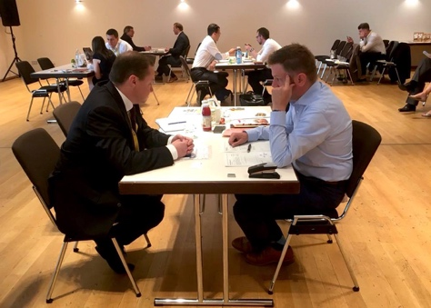

Technical part of the b2b venue:
- Big screen available for broadcasting video content
- Sound system
- 2 cordless microphones
- WI-FI

- Catering services.
For the pre-briefing: soft drinks (water)
For the B2B day: Tea, coffee, water and basic snacks available during B2B sessions (non – stop), lunch for up to 35 guests.
- Staff. Staff organized onsite to conduct the following tasks:
- Registration of guests
- Introducing participants of b2b to each other
- Distribution of materials
- Room set up
- Coordination of catering

