STUDY TOUR OF UKRAINIAN EXPORT-ORIENTED SMEs TO EU
[LITHUANIA + POLAND] [BALTIC COUNTRIES]

STUDY TOUR BACKGROUND:
Study Tour is organized by EBRD under the EU4Business initiative «Ukraine: Consolidation of SME export potential and facilitation of access to foreign markets».
Study Tour goal: to provide opportunities, educational and practical skills for export ready SME’s to enter new markets and rise/start export to EU, in particular:
- lecturer part: partner search, negotiations, competitive advantages, participation in trade B2B missions and international exhibitions, pricing, product development, export to EU etc.
- practical part: B2B meetings, participation in key exhibition [as visitors], sectoral site visits [retail store checks, enterprises and production visits/consultations with local business and experts, networking etc.].
Name: Study Tour: Go EU.
Sector: food & beverages.
Dates: April 2020.
Location: EU [Baltic countries] - Vilnius [LT] + Warsaw [PL].
Duration: up to 4-5 days
Participants description: up to 10 Ukrainian SMEs [maximum two participants from one enterprise].
Target audience: owners, top-managers, export managers of companies (SMEs).
Study Tour stages & tools:
- Export Education | Vilnius | 2 days*
- B2B matchmaking + Sectoral site visits: factory visit, store check | Vilnius | 2 days
- Exhibition visit: WorldFood Poland [21-23.04.2020] | Warsaw | 1 day
Language: English.
Contractor: Small or medium consulting companies [usually with up to 10 staff], specializing in import promotion to a foreign country; international business institutions, business schools, specializing in business education, in particular, on global trade (export/import) topics.
Costs: covered by the Project. Selected participants are paying for travel, accommodation and meals themselves.

Project timeline:
February 2020 – developing, finalizing and approving of detailed Study Tour Program.
February – March 2020 – Open call and application process for potential participants. Communication and promo activities.
March 2020 - Interviewing Study Tour applicants [if needed]. Finalizing the list of Study Tour participants from Ukrainian side.
March – April 2020 – lecturer and practical tools preparations: B2B, exhibition and sectoral site visits etc.
April 2020 – Study Tour conducted.
May 2020 - Final report provided.

Project draft program**:
April 2020 | Study Tour
Part I: Export Education | Vilnius [LT] | 2 days*
Day 1 | 9.00 (10.00) – 18.00
- Briefing for Ukrainian Participants.
- How to export to EU.
- Trade opportunities for Ukrainian food & beverages producers in Lithuania and Poland [Baltic countries].
- Evaluation of export capability. Export business model, development of export plan and strategy. Participants will need to develop their company’s export strategy and plan and analyse their current export business model.
- Selection and research of target market, export brand. Practical examples will be shown how to do market research and set target markets. Training also will include basics of company brand building in export and brand communication [B2B level]. Practical task will include creation of company’s information profile.
Day 2 | 9.00 (10.00) - 18.00
- Export marketing and partner attraction in target markets. Export marketing methods and organization of partner attraction process – partner identification, selection and communication. Participants will learn how to successful deal with first cold call when attracting new export clients. Home work – first call to previously selected potential partners.
- Negotiations and unique proposition for buyers. Competitive advantages of the product/company. Cultural aspects while dealing with local companies.
- Sales process organization and relationship building with clients. Sales process management and team motivation for reaching common export goals, CRM, organisation of successful business trip and client relationship building.
Part II: Export Practice | Vilnius [LT] | 2 days
Day 3 | 9.00 (10.00) - 18.00
- B2B matchmaking
- Sectoral site visits [tbc]: factory visit, store check
Day 4 | 9.00 (10.00) - 18.00
- B2B matchmaking [individual meetings - tbc]
- Sectoral site visits: factory visit, store check
Part III: Exhibition | Warsaw [PL] – 1 day
Day 4 [APRIL 21-23] | 9.00 (10.00) - 18.00
- Visiting WorldFood Poland. Group transfer

*Introduction part [Export Education] is also considered to be partly hosted in Kyiv or its program/duration could be optimized, based on Project team or Contractor recommendations.
**The program and list of topics are preliminary and will be improved by the Project team and Contractor.

CONTRACTOR TERMS OF REFERENCES
- Study Tour Program

Develop and implement detailed daily Study Tour Program, including hourly schedule.

The Program should include all specific subtopics, relevant to the aim of the Program, list of speakers, detailed info on B2B and site visits objects, timeline, logistics/transfers etc.

Program topics should be oriented on practical and sector market information, speakers should either have practical professional background and experience.

- Market intelligence materials [brief version]
Develop market guide – brief version.
The documents supposed to be ready before 1st of April.
The materials should be developed in a template provided by the project. Country profile should include at least brief info on:
- Countries profile — basic;
- Trade with Ukraine statistics overview;
- In-depth overview of the food & beverages sector in countries;
- Market segmentation, market trends;
- Consumer preferences / overview;
- Retailers overview;
- Import duties, import restrictions;
- Key regulatory bodies and regulations specific;
- Perspective products for export from Ukraine among preselected sector;
- Recommendations on how to enter the market for the products identified as perspective;
- Major industry events.

- Selection of Ukrainian companies
Conduct screening of applied Ukrainian SMEs [if needed], to select the SMEs, which will be most demanded, export ready to select up to 10 SMEs for participation in the Study Tour [usually up to 25 Skype calls 30 minutes each]. Provide feedback to each interviewed company.
- B2B organization

The target is to conduct at least 5 individual B2B meetings per SME.

- Provide a long list of prospective partners per each SME. The list must at least include: company name, website, company category, operation field, general contact information;
- B2B meeting scheduling. Develop draft B2B meetings schedule 1 week prior to visit — pre-final.
- Develop final B2B schedule – 2-3 days before the event;
- Provide updates to the participant and the project manager.
- Provide feedback to each company from the long list [why are they interested/not interested in taking part in the B2B event?].
It’s expected that Contractor will contact local companies while inviting a potential partner to B2B event.
- Site visits
To organize at least 3 site visits. The visits must be guided by the Contractor.
Please calculate a cost for group transportation separately.
- Business packages for each SME-participant

To develop business packages for each SME-participant. Must include:

- Study Tour Program, all needed info layouts.
- Individual B2B schedule.
- Short description of the companies coming for B2B [incl. personal contact information of the company’s representatives, position and sourcing preferences [what products company is looking for; preferable cooperation terms and conditions if we know them, recommendations if any].

The materials should be developed in a template provided by the Project, including Project visibility.

All online materials, presentations etc. during Education Program of the Study Tour should be shared with participants.

- Pre-briefing
To organize and conduct a briefing for the delegation on their arrival to Vilnius, before the B2B days and site visits.
To present organizational issues.
To present the B2B schedule: short description of the companies coming for B2B and buyers sourcing preferences.

- Seminar «Trade opportunities for Ukrainian food & beverages producers in Lithuania and Poland [Baltic countries] ».
To organize and conduct a seminar for the delegation on their arrival to Vilnius. The following information expected to be presented:
- Brief market overviews, incl. export – Import relation between Lithuania / Poland [Baltic countries] and Ukraine.
- Food consumption in local markets.
- Statistics regarding the prices for food & beverages.
- Statistic for offline and online sales. Main online and offline chain/platforms.
- What do buyers expect from the producers? What types of cooperation they are most interested in? What delivery terms are most preferable for buyers? What payment terms they expect?
- Requirements for importing production to local markets from Ukraine.
- Business culture. Cultural aspects.

- Reporting

Develop and provide the project report, no later than a week after the end of the mission. The report should at least include:
- The final schedule of conducted events, site visits, B2B meetings with contacts;
- List of the contacted companies within the project with contacts and the feedback;
- Challenges faced within the B2B preparations and recommendations for future events;
- Folder with presentations conducted during the trade mission program.
- Participants feedback forms, covering all Study Tour components events level of satisfaction.

- Venue
Organize the venue for the following activities:
- Export Education Program, pre-briefing etc.
- B2B matchmaking.

Preferable requirements for the venue for Export Education and the pre-briefing:

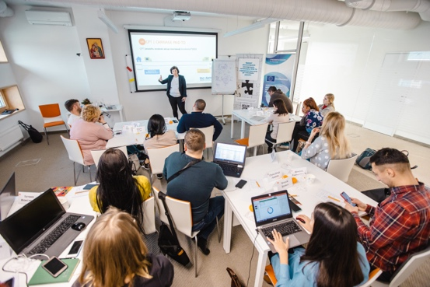
- Modern room, easy to access and find;
- Up to 50 people to accommodate;
- Theater style seating;
- Technical part of Export Education and pre-briefing venue: big screen available for broadcasting video content, sound system, 2 cordless microphones [if needed];
- WI-FI.

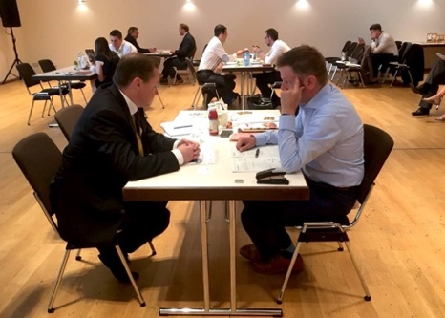
Preferable requirements for the venue for B2B session must be:
- Modern room, easy to access and find;
- Island style seating [12 big tables - 1 table per 1 company, registration desk, and zone for samples].
- Available catering services;
- Big screen available for broadcasting video content;
- Sound system;
- 2 cordless microphones;
- WI-FI.

- Catering services.
For the Export education and pre-briefing: coffee breaks [tea, coffee, basic snacks], lunches, soft drinks [water] during a day.
For the B2B days: Tea, coffee, water and basic snacks available during B2B sessions [non – stop], lunches.
- Staff.
Staff organized onsite to conduct the following tasks:
- Registration of guests, coordinating participants and Study Tour timeline, logistics.
- Introducing participants of B2B to each other.
- Distribution of materials.
- Room set up.
- Coordination of catering.

- Transportation services

- Transfers for site visits in Vilnius and local airport [if needed]. Bus for up to 30 people.
- Transfer to WorldFood Poland [if needed]. Bus for up to 30 people.

- Photo & video

- Possibility to provide professional photos and/or video materials of participants and key events of the Study Tour is a plus.

